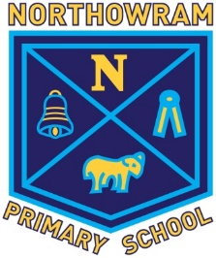
NORTHOWRAM PRIMARY SCHOOL

TERM DATES 2021-2022

2021 AUTUMN TERM  Training Day  Half Term  Training Day  Christmas | Closed  Re-open  Close at end of day  Closed  Re-open  Close at end of day | Monday 6th September  Tuesday 7th September  Thursday 21st October  Friday 22nd October  Monday 1st November  Friday 17th December
2022 SPRING TERM  Half Term  Training Day  Easter | Re-open  Close at end of day  Closed  Re-open  Close at end of day | Tuesday 4th January  Thursday 17th February  Friday 18th February  Monday 28th February  Friday 8th April
2022 SUMMER TERM  May Day  Half Term  Midsummer  Training Day  Training Day | Re-open  Closed  Close at end of day  Re-open  Close at end of day Closed  Closed | Monday 25th April  Monday 2nd May  Friday 27th May  Monday 6th June  Friday 22nd July  Monday 25th July  Tuesday 26th July

Please note: SATS take place during May please avoid this month for a family holiday.

Please retain this sheet for your future reference v1. Sept 2020

