Literacy long term planning - Autumn term.
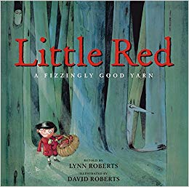  Traditional Tales unit:  Jack and th Beanstalk  Little Red  Hanzel and Gretl | Molly Rogers Pirate Girl  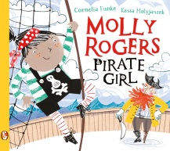 | 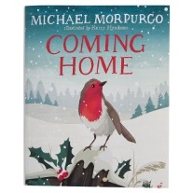  Coming Home
Writing Opportunities  - Retelling of traditional tales  - Character descriptions  - Setting descriptions  - Expanded noun phrases  - Planning and editing work  - Different sentence types: question, statement, exclamation, command  - Sub-ordination and co-ordination  - Using past and present tense correctly  - Creating own versions of traditional tales  - Full stops, capital letters ? ! commas for lists | Writing Opportunities  - Full stops, capital letters, ? ! commas for lists  - Diary entries  - Prepositions  - Expanded noun phrases  - Character descriptions  - Letter writing  - Sub-ordination and co-ordination  - Using past and present tense correctly  - Planning and editing work  - Different sentence types | Writing opportunities:  - Diary entries  - Using reading to inform writing  - Expanded noun phrases  - Full stop, capital letters, ?! commas  - Non-fiction writing about robins
Reading Opportunities  - Discussing and expressing views on traditional tales  - Discussing the sequence of events in a story  - Verbally retelling traditional tales  - Recognising recurring language in stories  - Inference work  - Answering and asking questions  - Participate in discussions about books that are read to them  - Explain and discuss what happens in stories that are read to them | Reading Opportunities  - Discussing and expressing views on stories  - Inference work  - Prediction work  - Answering and asking questions  - Participate in discussions about books that are read to them  - Explain and discuss what happens in stories that are read to them or that they read themselves  - Discussing the sequence of events in books | Reading opportunities  - Reading and discussing poetry  - Use my own experiences to make predictions  - Discussing favourite words and phrases  - Recognising simple language patterns in poems
Literacy long term planning – Spring term
Tell me a Dragon  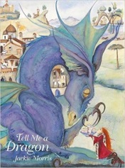 | Explanation texts (The Teacher pleaser/Cracking Contraptions)
Writing Opportunities  - Using different openers  - Similes and expanded noun phrases  - Description of dragon  - Non-fiction writing – non-chronological report about a dragon | Writing Opportunities  - Full stops, capital letters, ? ! commas for lists  - Sub-ordination and co-ordination  - Using past and present tense correctly  - Planning and editing work  - Different sentence types
Reading opportunities  - Sorting and ordering information about different dragons  - Discussing favourite words and phrases  - Discussing and clarifying the meaning of words  - Reading and discussing non-fiction texts  - Comprehension questions | Reading Opportunities  - Answering and asking questions  - Participate in discussions about books that are read to them  - Reading and discussing non-fiction texts  - Discuss the meaning of words  - Explain and discuss their understanding of a text

Literacy long term planning – Summer term
Mr Benn  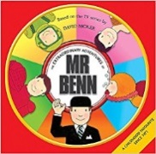 | Poetry Unit celebrating texts throughout the year | 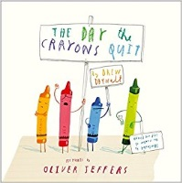  The Day the Crayons Quit
Writing Opportunities  - Full stops, capital letters, ? ! commas for lists  - Expanded noun phrases  - Character descriptions  - Setting descriptions  - Sub-ordination and co-ordination  - Using past and present tense correctly  - Planning and editing work  - Different sentence types  - Writing their own story | Writing Opportunities  - Writing poems  - Expanded noun phrases  Planning and editing work | Writing Opportunities  - Letter writing  - Full stops, capital letters, ? ! commas for lists  - Expanded noun phrases  - Planning and editing work  - Different sentence types  - Sub-ordination and co-ordination  - Using past and present tense correctly
Reading Opportunities  - Discussing and expressing views on stories  - Inference work  - Prediction work  - Answering and asking questions  - Participate in discussions about books that are read to them  - Explain and discuss what happens in stories that are read to them or that they read themselves  - Discuss the sequence of events in a story  - Recognise recurring language in stories | Reading Opportunities  - Discuss and express views on a range of poetry  - Recognising simple recurring literary language in poems  - Discuss and clarify the meaning of words  - Discuss their favourite words and phrases  - Say out loud poems they have learnt with appropriate intonation to make the meaning clear  - Participate in discussions about poems  Explain and discuss their understanding of poems | Reading Opportunities  - Discussing and expressing views on stories  - Inference work  - Prediction work  - Answering and asking questions  - Participate in discussions about books that are read to them  - Explain and discuss what happens in stories that are read to them or that they read themselves  - Discussing favourite words and phrases  - Discussing the meaning of words

