Year 3 English Long Term Plan Autumn Term
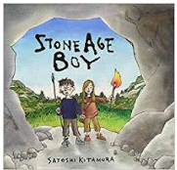  Stone Age Boy  - Instructions  - Summary | Objectives  - I can demarcate sentences using capital letters, full stops, question marks, exclamation marks and apostrophes for contraction and possession.  - I can use expanded noun phrases to describe and add detail to settings and characters  - I can use co-ordinating and subordinating conjunctions, adverbs or prepositions to express time, place and cause.  - I can use the correct tense consistently  - Use some pro-nouns and time adverbials to aid cohesion  - Use simple organisational devices e.g. subheadings  - Use a/an correctly  Reading  - I can discuss a range of text types which I have read or which have been read to me.  - I can predict events in stories based on what has happened in the story so far.  - I can make inferences to a characters feelings, thoughts and motives using clues from the text.  - I ask questions about the books we are studying.  - I use a dictionary to find the meaning of some new words in the books I am reading  - I have read a range of books.  - I can orally retell some stories.
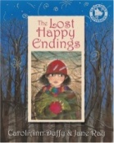  Lost Happy Endings  - Character descriptions  - Diary entry  - Story  - Setting descriptions | - I can demarcate sentences using capital letters, full stops, question marks, exclamation marks and apostrophes for contraction and possession.  - I can use expanded noun phrases to describe and add detail to settings and characters  - I can use co-ordinating and subordinating conjunctions, adverbs or prepositions to express time, place and cause.  - I can use the correct tense consistently  - Use some pro-nouns and time adverbials to aid cohesion  - Use simple organisational devices e.g. subheadings  - Use a/an correctly  - I can use inverted commas to punctuate speech.  Reading  - I can discuss a range of text types which I have read or which have been read to me.  - I can discuss interesting words and phrases the author has used.  - I can predict events in stories based on what has happened in the story so far.  - I can identify common themes and conventions in the stories I have read.  - I can make inferences to a characters feelings, thoughts and motives using clues from the text.  - I ask questions about the books we are studying.  - I use a dictionary to find the meaning of some new words in the books I am reading  - I have read a range of books.  - I can orally retell some stories.
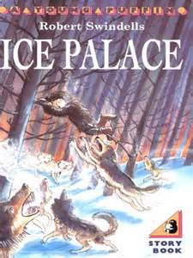  Ice Palace  - Predictions  - Setting description  - Letter writing  - Poetry.  - Instructions.  - Quest story | - I can demarcate sentences using capital letters, full stops, question marks, exclamation marks and apostrophes for contraction and possession.  - I can use expanded noun phrases to describe and add detail to settings and characters  - I can discuss interesting words and phrases the author has used.  - I can use co-ordinating and subordinating conjunctions, adverbs or prepositions to express time, place and cause.  - I can use the correct tense consistently  - Use some pro-nouns and time adverbials to aid cohesion  - Use simple organisational devices e.g. subheadings  - Use a/an correctly  Reading  - I can discuss a range of text types which I have read or which have been read to me.  - I can predict events in stories based on what has happened in the story so far.  - I can make inferences to a characters feelings, thoughts and motives using clues from the text.  - I ask questions about the books we are studying.  - I use a dictionary to find the meaning of some new words in the books I am reading  - I have read a range of books.  - I can orally retell some stories.

Year 3 English Long Term Plan Spring Term
Ignis  - Predictions  - Discuss the author’s use of descriptive language and prepositional phrases.  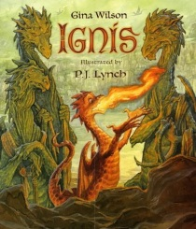  - Setting description  - Speech.  - Letter writing  - Present perfect tense  - Poetry  - Diary  - Write a non-chronological report | - I can demarcate sentences using capital letters, full stops, question marks, exclamation marks and apostrophes for contraction and possession.  - I can use expanded noun phrases to describe and add detail to settings and characters  - I can use co-ordinating and subordinating conjunctions, adverbs or prepositions to express time, place and cause.  - I can use the correct tense consistently  - I am beginning to use present perfect tense.  - Use some pro-nouns and time adverbials to aid cohesion  - Use simple organisational devices e.g. subheadings  - Use a/an correctly  - I can use inverted commas to punctuate speech.  Reading  - I can discuss a range of text types which I have read or which have been read to me.  - I can predict events in stories based on what has happened in the story so far.  - I can make inferences to a characters feelings, thoughts and motives using clues from the text.  - I ask questions about the books we are studying.  - I use a dictionary to find the meaning of some new words in the books I am reading  - I have read a range of books.  - I can orally retell some stories.  - I know that poetry comes in different forms.  - I can read and perform poems and playscripts.  - I can summarise the main idea from a page or section of a text I have read.
Leon and the Place Between  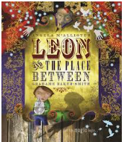  - Prediction  - Sentence structure  - Characters feelings  - Character description  - Letter writing  - Story writing | - I can demarcate sentences using capital letters, full stops, question marks, exclamation marks and apostrophes for contraction and possession.  - I can use expanded noun phrases to describe and add detail to settings and characters  - I can use co-ordinating and subordinating conjunctions, adverbs or prepositions to express time, place and cause.  - I can use the correct tense consistently  - Use some pro-nouns and time adverbials to aid cohesion  - Use a/an correctly  Reading  - I can discuss a range of text types which I have read or which have been read to me.  - I can predict events in stories based on what has happened in the story so far.  - I can make inferences to a characters feelings, thoughts and motives using clues from the text.  - I ask questions about the books we are studying.  - I use a dictionary to find the meaning of some new words in the books I am reading  - I have read a range of books.  - I can orally retell some stories.
Charlie and the chocolate factory  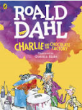  - Character description  - Setting description  - Newspaper reports  - Speech  - Predictions | - I can demarcate sentences using capital letters, full stops, question marks, exclamation marks and apostrophes for contraction and possession.  - I can use expanded noun phrases to describe and add detail to settings and characters  - I can use co-ordinating and subordinating conjunctions, adverbs or prepositions to express time, place and cause.  - I can use the correct tense consistently  - Use some pro-nouns and time adverbials to aid cohesion  - Use simple organisational devices e.g. subheadings  - Use a/an correctly  Reading  - I can discuss a range of text types which I have read or which have been read to me.  - I can predict events in stories based on what has happened in the story so far.  - I can make inferences to a characters feelings, thoughts and motives using clues from the text.  - I ask questions about the books we are studying.  - I use a dictionary to find the meaning of some new words in the books I am reading  - I have read a range of books.  - I can orally retell some stories.  - I can summarize the main idea from a section or page I have read.

Year 3 English long term plan summer term
Charlie and the chocolate factory continued  - Character description  - Setting description  - Newspaper reports  - Speech  - Predictions | As above
Lion and the unicorn  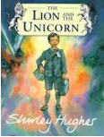  - Diaries  - Descriptive settings  - Inference  - Author’s use of language  - Noun phrases  - Connectives  - Present perfect tense  - Prediction  - Summary | - I can demarcate sentences using capital letters, full stops, question marks, exclamation marks and apostrophes for contraction and possession.  - I can use expanded noun phrases to describe and add detail to settings and characters  - I can use co-ordinating and subordinating conjunctions, adverbs or prepositions to express time, place and cause.  - I can use the correct tense consistently  - Use some pro-nouns and time adverbials to aid cohesion  - Use a/an correctly  - I am beginning to use present perfect tense.  Reading  - I can discuss a range of text types which I have read or which have been read to me.  - I can predict events in stories based on what has happened in the story so far.  - I can make inferences to a characters feelings, thoughts and motives using clues from the text.  - I ask questions about the books we are studying.  - I use a dictionary to find the meaning of some new words in the books I am reading  - I have read a range of books.  - I can summarize the main idea from a page or text I have read.

