Literacy long term planning - Autumn term.
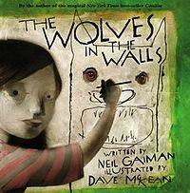  The Wolves in the Walls - Neil Gaiman | 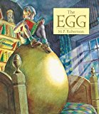  The Egg – M.P. Robertson | 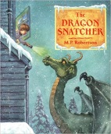  The Dragon Snatcher – M.P Robertson
Writing Opportunities  - Suspense story  - Non-Chronological report  - Description  - Planning, drafting, organising into paragraphs and editing  - Play-script  - Speech  - Discussion | Writing Opportunities  - Full stops, capital letters, ? !  - Expanded noun phrases – setting or characters  - Adverbials  - Paragraphs  - Conjunctions, adverbs, prepositions  - Speech, commas for fronted adverbials, apostrophes  - Planning, drafting, organising into paragraphs and editing  - Descriptions | Writing Opportunities  - Full stops, capital letters, ? !  - Expanded noun phrases – setting or characters  - Adverbials  - Paragraphs  - Conjunctions, adverbs, prepositions  - Speech, commas for fronted adverbials, apostrophes  - Planning, drafting, organising into paragraphs and editing  - Description  - Non-fiction encyclopaedia  - Character description  - Story Writing
Reading Opportunities  - read my writing out loud to an audience in an interesting and clear manner  - I can predict  - I can ask questions  - I can summarise what has happened in the story so far  - I can discuss a range of text types which I have read or have been read to me  - I can discuss interesting words, phrases and layout the author has used  - I can make inferences to a character’s feelings, thoughts and motives using clues from the text. | Reading Opportunities  - I can use a dictionary  - I can discuss interesting words and phrases that the author has used  - I can explain the meaning of words  - I can ask questions  - I can predict  - I can discuss a range of text types which I have read or have been read to me  - I can read books which are set out in different ways and use these to find information (instructions/encyclopedia entry)  - I can describe how books are set out in different ways to help the reader  - I can make inferences to a character’s feelings, thoughts and motives using clues from the text  - I can summarise the main idea of something I have read (summarise book 1) | Reading Opportunities  - I can use a dictionary  - I can discuss interesting words and phrases that the author has used  - I can explain the meaning of words  - I can ask questions  - I can predict  - I can discuss a range of text types which I have read or have been read to me  - I can describe how books are set out in different ways to help the reader  - I can make inferences to a character’s feelings, thoughts and motives using clues from the text

Literacy long term planning – Spring term
Beowulf - Michael Morpurgo
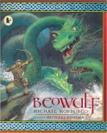
Writing Opportunities
- Full stops, capital letters, ? !
- Expanded noun phrases/Adverbials – setting or characters
- Adverbials
- Paragraphs
- Conjunctions, adverbs, prepositions
- Pronouns
- Speech, commas for fronted adverbials, apostrophes
- Character description
- Story retelling
Reading Opportunities
- I can use a dictionary
- I can discuss interesting words and phrases that the author has used
- I can explain the meaning of words
- I can ask questions
- I can predict
- I can discuss a range of text types which I have read or have been read to me
- I can read books which are set out in different ways and use these to find information
- I have read a range of books including fairy tales, myths and legends – I can orally retell some of these stories
- I can read and PERFORM poems and playscripts – write and perform or possible perform parts of the one from website above
- I can describe how books are set out in different ways to help the reader
- I can make inferences to a character’s feelings, thoughts and motives using clues from the text
- I can summarise the main idea of something I have read

Literacy long term planning – Summer term
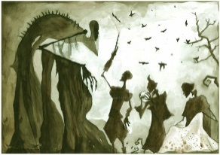  The Tale of the Three Brothers – JK Rowling | The Iron Man – Ted Hughes  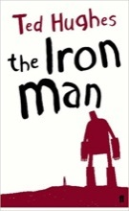
Writing Opportunities  - Full stops, capital letters, ? !  - Expanded noun phrases/Adverbials – setting or characters  - Adverbials  - Paragraphs  - Conjunctions, adverbs, prepositions  - Pronouns  - Speech, commas for fronted adverbials, apostrophes  - Essay  - Retelling from a different character’s point of view  - Diary entry  - Description | Writing Opportunities  - Full stops, capital letters, ? !  - Expanded noun phrases/Adverbials – setting or characters  - Adverbials  - Paragraphs  - Conjunctions, adverbs, prepositions  - Pronouns  - Speech, commas for fronted adverbials, apostrophes  - Diary  - Play-script  - News report  - Recount  - Persuasion
Reading Opportunities  - can use a dictionary  •I can discuss interesting words and phrases that the author has used  •I can explain the meaning of words  •I can ask questions  •I can predict  •I have read a range of books including fairy tales, myths and legends – I can orally retell some of these stories  •I can make inferences to a character’s feelings, thoughts and motives using clues from the text | Reading Opportunities  • I can use a dictionary  • I can discuss interesting words and phrases that the author has used  • I can explain the meaning of words  • I can ask questions  • I can predict  - can summarise the main idea of something I have read  - •I can make inferences to a character’s feelings, thoughts and motives using clues from the text

