Year 5 English Long Term Plan – Autumn
Text | Cover | Writing opportunities | Reading opportunities
The Boy, the Dog and the Frog – Mercer Mayer | 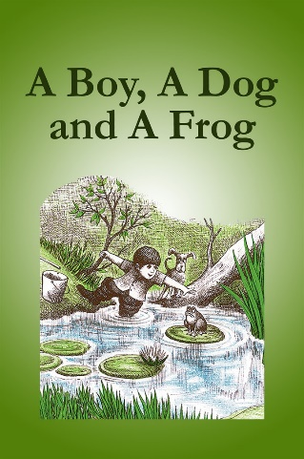 | - Full stops, capital letters, ? !  - Paragraphs  - Description  - Speech  - Planning, drafting, organising into paragraphs and editing  - Cohesive devises  - Story | - I can ask questions  - I can predict  - I can read books which are set out in different ways and use these to find information  - I can describe how books are set out in different ways to help the reader  - I can make inferences to a character’s feelings, thoughts and motives using clues from the text  - I can make INFERENCES such as inferring characters’ feelings, thoughts and motives from their actions. I find EVIDENCE in the text to support my views
Clockwork – Philip Pullman | 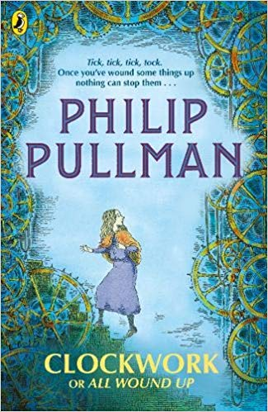 | - Setting description  - Planning, drafting, organising into paragraphs and editing  - Essay  - Summary  - Discussion, debate etc. | - I can identify and discuss THEMES in a text and find common themes across different texts  - I can use a dictionary  - I can predict  - I can ask questions  - I can summarise what has happened in the story so far  - I can make inferences to a character’s feelings, thoughts and motives using clues from the text.  - I participate in DISCUSSIONS about books I have read or that have been read to me, building on my own and others’ views  - I can discuss and DEBATE topics and themes I have read about  - I can EXPLAIN MY VIEWS about the topics, themes, characters and events in the texts I have read
The Snowman – Raymond Briggs | 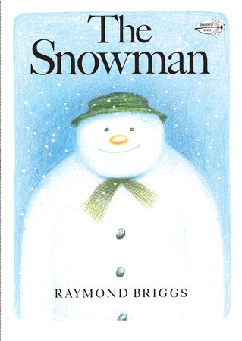 | - Full stops, capital letters, ? !  - Paragraphs  - Description  - Speech  - Planning, drafting, organising into paragraphs and editing  - Cohesive devises  - Story | - I can ask questions  - I can predict  - I can read books which are set out in different ways and use these to find information  - I can describe how books are set out in different ways to help the reader  - I can make inferences to a character’s feelings, thoughts and motives using clues from the text  - I can make INFERENCES such as inferring characters’ feelings, thoughts and motives from their actions. I find EVIDENCE in the text to support my views
Year 5 English Long Term Plan – Spring
Text | Cover | Writing opportunities | Reading opportunities
Billionaire Boy – David Walliams | 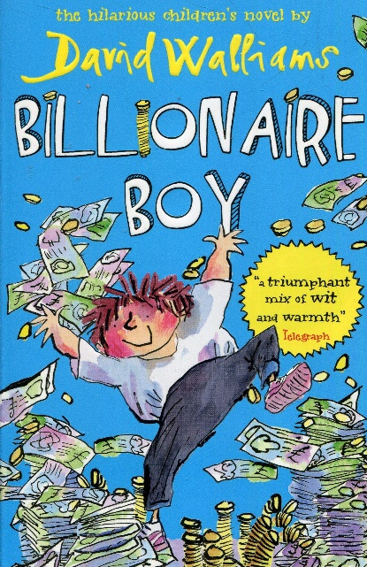 | - Full stops, capital letters, ? !  - Fact file  - Paragraphs  - Parenthesis  - Relative clauses  - Precis  - Character description  - Story retelling | - I can use a dictionary  - I can explain the meaning of words  - I can ask questions  - I can predict  - I can discuss a range of text types which I have read or have been read to me  - I can read books which are set out in different ways and use these to find information  - I have read a range of books including fairy tales, myths and legends – I can orally retell some of these stories  - I can describe how books are set out in different ways to help the reader  - I can make inferences to a character’s feelings, thoughts and motives using clues from the text  - I can summarise the main idea of something I have read  - I can make COMPARISONS within and between books I have read  - I can identify and discuss THEMES in a text and find common themes across different texts
Year 5 English Long Term Plan – Summer
Text | Cover | Writing opportunities | Reading opportunities
The Highwayman – Alfred Noyes | 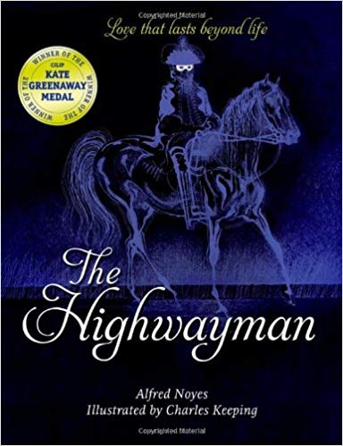 | - Full stops, capital letters, ? !  - Modal verbs  - Paragraphs  - Figurative language  - Personification  - Speech, apostrophes  - Poetry  - Fact file  - Story  - Description  - Newspaper | - I can use a dictionary  - I can explain the meaning of words  - I can ask questions  - I can predict  - I have read a range of books including fairy tales, myths and legends – I can orally retell some of these stories  - I can make inferences to a character’s feelings, thoughts and motives using clues from the text8) I have learned some POEMS by heart and can recite them  - I can add meaning to a text (poem, story or play) by reading/ performing it out loud  - I participate in DISCUSSIONS about books I have read or that have been read to me, building on my own and others’ views

