Literacy year 6 long term planning - Autumn term.
Rose Blanche - Christophe Gallaz and Roberto Innocenti | 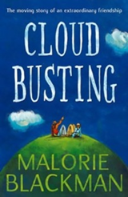  Cloud Busting  - Malorie Blackman | 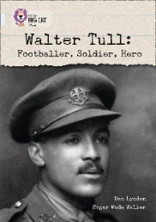  Walter Tull  - Dan Lyndon | 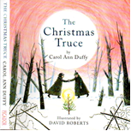  The Christmas Truce  – Carol Ann Duffy
Writing Opportunities  - Description  - Diary entry | Writing Opportunities  - Informal letter  - Formal letter  - Poetry writing | Writing Opportunities  - Biography | Writing Opportunities  - Poetry writing  - Memory flashback
Reading Opportunities  - I can predict using clues and prior knowledge  - I can ask questions  - I can discuss a range of text types which I have read or have been read to me  - I can explain how form, imagery and word choice contribute to meaning  - I can make inferences to a character’s feelings, thoughts and motives using clues from the text.  - I can comment on the author’s use of language  - I can consider the impact of language on the reader  - I can read my writing out loud to an audience in an interesting and clear manner | Reading Opportunities  - I can use a dictionary  - I can explain the meaning of words  - I can ask questions  - I can summarise information  - I can summarise chapters  - I can predict using clues and prior knowledge  - I can discuss a range of text types which I have read or have been read to me  - I can make inferences to a character’s feelings, thoughts and motives using clues from the text.  - I can comment on the author’s use of language  - I can consider the impact of language on the reader  - I can show understanding of the text through my intonation, tone and volume | Reading Opportunities  - I can use a dictionary  - I can read and discuss non fiction texts  - I can retrieve and record information from non-fiction  - I can distinguish between statements of fact and opinion  - I can discuss interesting words and phrases that the author has used  - I can explain the meaning of words  - I can ask questions  - I can describe how books are set out in different ways to help the reader | Reading Opportunities  - I can use a dictionary  - I can explain the meaning of words  - I can ask questions  - I can summarise information  - I can predict using clues and prior knowledge  - I can discuss a range of text types which I have read or have been read to me  - I can make inferences to a character’s feelings, thoughts and motives using clues from the text.  - I can comment on the author’s use of language  - I can consider the impact of language on the reader  - I can identify themes in a text and find common themes

Literacy long term planning – Spring term
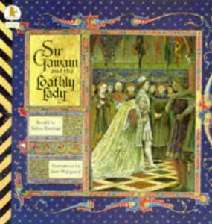  Sir Gawain and the Loathly Lady  - Selina Hastings | 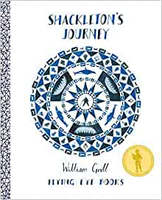  The Journey of Shackleton  - William Grill
Writing Opportunities  - Essay  - Story writing – retelling the story  - Integrating dialogue into a story | Writing opportunities  New unit for this year will incluce  - Newspaper report  - Non chronological information report
Reading Opportunities  - I can use a dictionary  - I can explore themes in a text  - I can identify different types of nouns  - I can identify how words and phrases contribute to meaning  - I can explain the meaning of words  - I can ask questions  - I can predict  - I can discuss a range of text types which I have read or have been read to me  - I have read a range of books including fairy tales, myths and legends – I can orally retell some of these stories  - I can make inferences to a character’s feelings, thoughts and motives using clues from the text.  - I can comment on the author’s use of language  - I can consider the impact of language on the reader  - I can summarise the main idea of something I have read | Reading opportunities  New unit for this year will include  - I can use a dictionary  - I can read and discuss non fiction texts  - I can retrieve and record information from non-fiction  - I can distinguish between statements of fact and opinion  - I can discuss interesting words and phrases that the author has used  - I can explain the meaning of words  - I can ask questions  - I can describe how books are set out in different ways to help the reader
Literacy long term planning – Summer term
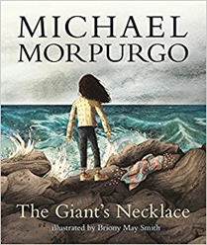  The Giant’s Necklace  – Michael Morpurgo | 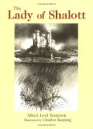  The Lady of Shallot -  Alfred Tennyson
Writing Opportunities
- Newspaper report
- Diary
Reading Opportunities  - I can use a dictionary  - I can explain the meaning of words  - I can ask questions  - I can summarise information  - I can predict using clues and prior knowledge  - I can discuss a range of text types which I have read or have been read to me  - I can make inferences to a character’s feelings, thoughts and motives using clues from the text.  - I can comment on the author’s use of language  - I can consider the impact of language on the reader  - I can identify themes in a text and find common themes | Reading Opportunities  - I can use a dictionary  - I can explain the meaning of words  - I can ask questions  - I can summarise information  - I can summarise chapters  - I can predict using clues and prior knowledge  - I can discuss a range of text types which I have read or have been read to me  - I can make inferences to a character’s feelings, thoughts and motives using clues from the text.  - I can comment on the author’s use of language  - I can consider the impact of language on the reader  - I can show understanding of the text through my intonation, tone and volume

