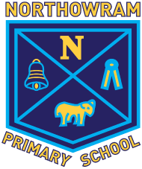
Northowram Primary School D and T Long Term Curriculum Map (from Sept 2021)
*Please note that additional Cooking and Nutrition topic will be taught over an allocated week throughout the year in each year group
Year | Autumn 1 | Autumn 2  MECHANISMS | Spring 1 | Spring 2  STRUCTURES | Summer 1 | Summer 2  TEXTILES | Cooking and Nutrition
Nursery | Child initiated model making – animal focus | Bird feeders. | Model rockets | Mother’s Day card with mechanism | Model pirate ships | Sock puppets | Vegetable soup
Reception | Child initiated model making – animal focus | Design and make a 3D broomstick. | Model pirate ships | Split pin puppets | Jack and the Beanstalk sliders | Material superhero masks | Make a healthy sandwich
1 |  | Moving storybook: Sliders  Wheels and Axels |  | Windmills |  | Puppets | Fruit and Vegetable Smoothie
2 |  | Moving Monsters  Fairground Wheels |  | Baby Bear’s chair |  | Pouches | A balanced diet
3 |  | Pneumatic toys |  | Constructing a castle |  | Cushions | Eating Seasonally
4 |  | Making a sling shot car |  | Pavilions |  | Fastenings | Adapting a Recipe
5 |  | Making a pop-up book |  | Bridges |  | Stuffed toys | What could be Healthier?
6 |  | Automata toys |  | Playgrounds |  | Waistcoats | Come Dine with Me

