Northowram Primary School
Pupil Premium Report
March 2019 - March 2020
‘The disadvantaged pupils’ team rigorously monitors the progress of vulnerable pupils, reporting on their work to the linked governor. As a result of this cohesive approach, disadvantaged pupils achieve as well as other pupils.’ (OFSTED 2016)
The government currently allocates additional funding to schools in the form of ‘The Pupil Premium’. One of the criteria used to calculate this additional funding is the number of pupils at a school who receive or who have ever received Free School Meals (FSMs).
The Pupil Premium is a grant provided to enhance educational opportunity for children in families of lower income. This additional funding is paid to schools in respect of their disadvantaged pupils (which includes pupils who have been registered for free school meals at any point in the last six years, looked after children, adopted pupils and service children).
Schools use this funding to narrow any attainment gap between these children and their peers.
Context of School
Northowram Primary School serves a predominantly white British ward in Calderdale. Although most families live within the village, a significant number of children attend our school and live in other areas including Bradford and North Halifax. It is a larger than average school with 459 pupils on roll. The number of pupils known to be eligible for free school meals is low placing the school in the lowest quintile compared to other schools nationally. The school’s deprivation factor is below national averages. Most pupils who attend the school are White British. Although the number of pupils with SEN is low compared with other schools, the number of children with a statement of Special Educational Needs is similar to schools nationally.

Vision, Aims and Principles

Our aims and principles for the spending of the Pupil Premium grant are guided by our school vision statement:

- All pupils will make progress which is beyond expectation
- Pupils will be encouraged to see their potential for improvement from any starting point
- Pupils will be motivated to achieve ambitions both in and out of school
- Pupils will receive strong and skilled personal guidance to support the achievement of higher outcomes

In addition, the following are used as guiding principles when considering the most efficient and effective way to spend the Pupil Premium grant:

- We ensure that appropriate provision is made for pupils who belong to vulnerable groups – this includes ensuring that the needs of socially disadvantaged pupils are adequately assessed and addressed.
- In making provision for socially disadvantaged pupils, we recognise that not all pupils who receive (or have received) free school meals will be socially disadvantaged.
- We also recognise that not all pupils who are socially disadvantaged are registered or qualify for free school meals. We reserve the right to allocate Pupil Premium funding to support any pupil or groups of pupils the school has legitimately identified as being socially disadvantaged.
- Pupil Premium funding will be allocated following a needs analysis which will identify priority classes, groups or individuals. Limited funding and resources means that not all children receiving free school meals will be in receipt of Pupil Premium interventions at one time.

To achieve these aims, the Pupil Premium grant will be spent in a wide variety of ways including:

- Funding additional staff roles specifically designed to safeguard and promote the well-being of vulnerable children including socially disadvantaged children.
- Providing small group or 1:1 work with an experienced teacher focussed on overcoming gaps in learning and narrowing any gap between the child/ren and age-related expectations
- Providing small group or 1:1 work with an experienced teacher focussed on accelerating learning to above age related expectations
- Additional Teaching Assistant support in lessons aimed at accessing age-related learning
- Acquiring effective materials aimed at raising standards and narrowing any attainment gap, particularly in reading, writing and mathematics
- Funding learning opportunities outside of school including sporting clubs, residential visits and musical and 1:1 tuition.

Roles and Responsibilities
Disadvantage Pupils Team
Pupil Premium Manager – Laura Horsfall (Deputy Headteacher)
To ensure that audit, monitoring, action planning and development linked to the allocation of the Pupil Premium grant is in place and is effectively overcoming any barriers which disadvantage might create.
To support and direct staff within the Disadvantaged Pupils Team - in using effective strategies to overcome barriers to learning for disadvantaged pupils and their families.
To analyse pupil data linked to attainment and achievement, attendance and punctuality for all disadvantaged pupils producing half termly reports.
To manage the Pupil Premium grant budget including authorising all purchases.
To regularly report (on the above) to staff, leadership team and governors.
School Office Manager - Julia Lindsey
To work with the Pupil Premium Manager to manage and report the use of the Pupil Premium Grant budget.
The Leadership Team
To be responsible for policy development, curriculum planning and the monitoring of standards linked to disadvantaged pupils.
Pupil Premium Teaching Assistants – Helen Gray, Lindsey Lewis and Lisa Biggs
Under the direction of the Pupil Premium Manager, to plan/deliver/evaluate interventions, source resources and monitor the progress of disadvantaged pupils.
To work directly with disadvantaged pupils using a wide range of social and academic intervention.
To communicate regularly with parents about the range of support (intervention/resources/links to other agencies) which is on offer for children eligible for the Pupil Premium Grant and work with them to identify how additional funds can be used most effectively to meet the needs of individual children and families.
To provide an on-going contact point for parents and children eligible for the Pupil Premium grant.
To liaise with class teachers about the content and progress of additional work and resources with disadvantaged pupils.

Designated Safeguarding Lead/Head of Pastoral Care - Jane Jennings
To liaise with the Pupil Premium Manager to manage (including communication with parents) any safeguarding issues relating to disadvantaged pupils and their families include the monitoring of attendance and punctuality.
To manage referrals for disadvantaged pupils to Learning Mentors and external agencies
Learning mentors – Anne Taylor and Kathryn Scott
Under the direction of the DSL and Pupil Premium Manager, to provide a wide range of social and emotional support and intervention for children including disadvantaged pupils on any pastoral issue this may affect academic progress and personal well-being.
Governing Body: Link Governor for Pupil Premium – Marcus Rathbone
To challenge and support the school leadership team to ensure that the aims and principles of the school’s support for disadvantaged pupils are met.
To ensure that an on-going focus on Pupil Premium and disadvantaged pupils is included in each full governing body meeting and in sub-committees of School Improvement and Finance and General Purpose.

Expenditure 2019- 2020

Summary information
Academic year | 2019-2020 | Total PP budget | £70,080.83
Total number of pupils | 461 | Numbers of pupils eligible for PP | 49

Current attainment data (Summer 2019)
Early years (end of Reception year data)
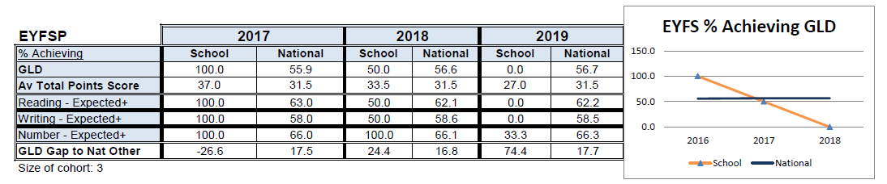
Phonics screening
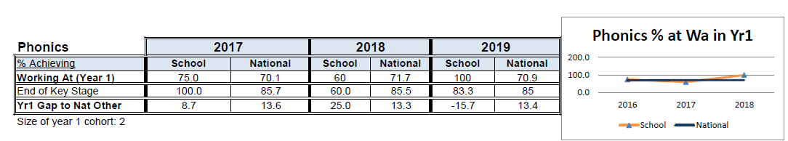

End of KS1
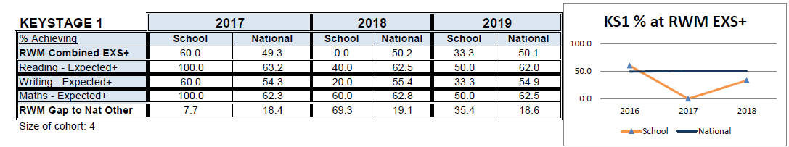

End of KS2
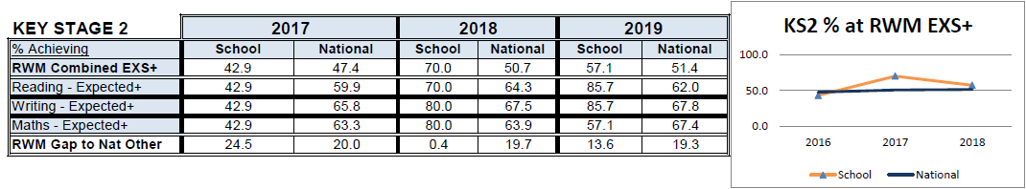

Barriers to future learning (for pupils eligible for PP including higher ability)
Barrier to learning
A | Low attainment on entry of PP children
B | Significant numbers of children requiring emotional support to be able to access learning
C | Children will be disadvantaged because of home financial constraints (personal equipment)
D | Children’s experiences are limited due to home financial constraints

Academic year 2019- 2020
Total income £58.980
Including 10,000 and carry forward from 2018- 2019- £11,100.83
TOTAL- £70,080.83
Item | Cost
Pivotal training *carried over from 2018- 2019 | £10,000
Staffing-  Pupil premium support assistants  Pastoral learning posts (Including contribution towards salary of Head of Pastoral Care and 2 x part time learning mentor posts)  Staffing for forest schools  Support staffing costs (1 % of support staff)  Overtime paid for extra interventions (rainbows and sunbeams) | £34.500  £9,000  £800.00  £4,000  £340
School trips including Howtown residential | £505.65
Forest schools | £3,000
School uniform | £807.75
Extra-curricular activities  Drums  Judo  TAGS camp | £226  £75  £62.50
1:1 therapy sessions | £240
1:1 tuition | £450
Educational psychologist | £450
Teaching and learning resources  - Spelling logbooks  - Weighted resources  - Stationery  - Wavy tactile path  - GCP homework books  - Sports equipment  - Books | £1,117.59  £313.72  £250.14  £158.95  £2,203.50  £51.92  £4.00
Other  - YPO and TTS resources for PP room  - Sports equipment  - Food (including baking resources and snack for HW club)  - Amazon orders for PP resources | £645.78  £51.92  £2.42  £113.21
Rainbows and Sunbeams resources | £71.20
Play therapy sessions | £800
 | TOTAL SPEND- £70,241.25 (£160 overspend)

Outcome | Desired outcomes | Success criteria
A | To increase attainment and progress in Maths and in English (Reading, Writing, SPAG to narrow the gap between PP and national non-PP groups in all year groups. | At the end of KS2 the gap between PP children and non – PP children in school will be reduced and the gap between non-PP children nationally will begin to close.  In EY and KS1 outcomes gap will close between non-PP children nationally.
B | No difference in the engagement of PP and non-PP pupils in lessons – measured through lesson observations and classroom behaviour logs. | All children will receive support they need and there will be no difference between % of children who are PP and % of children who are not PP.
C | Pupils receive support within school and develop personal skills to overcome personal barriers. Pupils will become more aware of how to keep themselves mentally healthy. | Children are able to talk about and deal with their emotions effectively and this will have a lesser impact on their day-today school life.
D | Pupils take part in trips and enrichment activities to extend their personal experiences including after school clubs and extra-curricular activities. | No child is disadvantaged due to home circumstance.
E | Every child has the correct equipment to succeed in school e.g. uniform, PE kit | Children have a sense of pride in themselves and school.
F | PP children have a sense of pride and have high aspirations for themselves and other members of the school community. | Children have high aspirations of themselves and their future regardless of their circumstances at home.

Quality of teaching for all
Desired outcome | Chosen action/approach | What is the evidence and rationale for this choice? | How will you ensure it is implemented well? | Staff lead | When will you review implementation?
B | Pivotal behaviour training | To develop a consistent behaviour strategy across school. | Pivotal will provide training sessions for staff and actions to implement. | JS | Throughout the year through lesson observations.
A/ B | Increased number of adult support in the classroom in some year groups with high numbers of PP children in them (Year 1 and Year 2) | Children whose progress slows or are not at ARE receive additional targeted interventions and in class support to ensure that no child is left behind academically. | Children’s progress reviewed at rigorous pupil expectations and progress meetings.  Children targeted and tracked. | LH

Targeted support
Desired outcome | Chosen action/approach | What is the evidence and rationale for this choice? | How will you ensure it is implemented well? | Staff lead | When will you review implementation?
A/B/ C | Pastoral and PP team support vulnerable learners. | Removal of barriers linked to PP children to ensure access to our curriculum. | PP children with individual plan access learning.  Meet PP team half termly to review progress of the children.  Track the children’s progress through logs. | LH/ JJ/ AB | Ongoing
E | Children in receipt of PP grant receive uniform. | No children are disadvantaged by home circumstance. | PP children receive vouchers and use of vouchers is monitored. LH to work with office staff to ensure this.  Regular monitoring of uniform in school. | LH | N/A
A/ B | PP support team to ensure children do not have gaps in learning including; one to one precision teaching, one to one support. | Children whose progress slows or are not at ARE receive additional targeted interventions to make sure that no child is left behind academically. | Children’s progress reviewed at rigorous pupil expectations and progress meetings.  Children targeted and tracked. | LH | At pupil progress meetings throughout the year.
C/D/F | Forest schools | Children who have identified social and emotional barriers to learning to be provided with the opportunity to learn skills such as resilience, teamwork, safety etc | PP children will be selected with the pastoral lead to ensure the correct group of children are targeted.  Monitoring of the sessions and discussions with the children.  Pupil voice used to evidence impact. | LH/ JJ/ IW | Every half term the children will be reviewed.
D | Extra curriculum activities. | Children who are unable to access these activities out of school are provided with the opportunities to learn something new in school e.g. drums, judo. | Identify children who would benefit from extra-curricular activities.  Activities to be offered to these families and paid for. | LH/ HN | Ongoing monitoring looking at the number PP children being offered after school clubs / e.g. % of PP children.
C | Learning mentors to be used to support PP children with social and emotional issues. | Social and emotional support to be provided for children with difficult home lives.  Opportunities to be provided to support the children in these circumstances. | Identify children with the support of the pastoral lead.  Review children regularly.  Sessions to be logged on CPOMS when appropriate and followed up.  Sessions to be available to the children on a weekly basis. | JJ/ KS/ AT | Review of the children termly.
A/C | External agency support for children with identified needs. | Identified PP children to be identified for external support e.g. Education psychologist, 1:1 tuition, play therapy. | Children to be identified with working closely with SEND to identify cross overs between PP and SEND.  Working in partnership with parents to discuss concerns and support. | LH/ AB/ PP team | Reviewed at SEND termly reviews.  Reviewed at PP team meetings
E | Provide children with resources in school that will enhance and support their learning including providing children with spelling and homework books | Ensure that all children are provided with the correct resources and equipment to enhance their learning and improve their progress. | Review resources throughout the year.  Work alongside SEND lead and PP team to ensure that the staff have the correct resources to deliver interventions and support children in the classrooms. | LH/ PP team | Throughout the year
C | Provide targeted play therapy sessions for selected children. | To support children by providing them strategies to deal with their feelings and emotions. | Children to be identified with the support of the pastoral manager.  Sessions to be reviewed after 8 weeks.  Meet parents before the sessions start and afterwards. | LH and CP | Spring 2

Other approaches
Desired outcome | Chosen action/approach | What is the evidence and rationale for this choice? | How will you ensure it is implemented well? | Staff lead | When will you review implementation?
D/F | Trips and events are subsidised or paid for to ensure that all children have access to enrichment activities (including residential). | Children will have the experiences to impact on the wider curriculum at school. | Monitor the children/ year groups attending trips.  Provide support for parents with paying for trips/ residentials and extra events. | LH | Ongoing monitoring looking at the number PP children attending residential and contribution to school trips.

Impact of Pupil Premium spend
We monitor and measure the impact of our pupil premium spend and strategy in a range of ways including:
- Intervention monitoring (impact sheets)- The impact of all interventions (group and 1:1) is monitored which allows us to evaluate the effectiveness of the additional support we provide. Current interventions evaluated as being especially successful are teacher-led small group additional support in Reading and Writing, homework club, SULP groups (social use of language) and teaching assistant-led 1:1 bespoke interventions based on pupil need in a range of academic, social and pastoral areas. Interventions ran between September 2019- March 2020. These interventions paused in March 2020 due to Covid 19. As a result of this the children were unable to complete their interventions to the end of the year.
- Pupil, parents, staff feedback
- Progress and attainment data- The progress and attainment data for 2019- 2020 is unavailable. This is due to Covid 19 and lockdown of schools in March 2020. The progress and attainment data for the end of 2019- 2020 was not completed and therefore assessing the impact of intervention for our pupil premium children is not possible.
The impact of some of the interventions can be measured by pupil voice. This has been recorded in the table below.
Forest schools | Child A- KS2  “Forest Schools is fun and another chance to work with my friends. We work together to make things twigs hearts, poppies out of natural materials, bug hotels. I learnt listening skills, resilience, team works skills and it helped with my emotions. I also learnt to be enjoy the outdoors.”  Child B- KS1  “In Forest Schools I liked to build things- dens and plan areas. I enjoyed making a fire a roasting marshmallows. I learnt about nature and where worms lived. I learnt good listening kills and how to work in a team.”
Music tuition- samba | Child A- KS1  “I enjoyed samba lessons. I learnt to use different instruments to play a tune. My favourite part was drumming. I had to keep on trying if I found something difficult. I had to work as part of a team and on my own. I learnt listening skills and how to work with my group.”
Learning mentor support | Child A- KS2  “The learning mentor has helped me because she sorts out things that are bothering me. It makes me feel good because I know it will help me and make an improvement.”  Child B- KS2  “The learning mentor has helped me when I had problems at home. Sometimes I get angry and when I go to see her I can tell her it helps me be more calmer. I would tell anyone who needs help to see Mrs Taylor because she has helped me.”

