Northowram Primary School
Pupil Premium Report
March 2020 - March 2021
‘The disadvantaged pupils’ team rigorously monitors the progress of vulnerable pupils, reporting on their work to the linked governor. As a result of this cohesive approach, disadvantaged pupils achieve as well as other pupils.’ (OFSTED 2016)
The government currently allocates additional funding to schools in the form of ‘The Pupil Premium’. One of the criteria used to calculate this additional funding is the number of pupils at a school who receive or who have ever received Free School Meals (FSMs).
The Pupil Premium is a grant provided to enhance educational opportunity for children in families of lower income. This additional funding is paid to schools in respect of their disadvantaged pupils (which includes pupils who have been registered for free school meals at any point in the last six years, looked after children, adopted pupils and service children).
Schools use this funding to narrow any attainment gap between these children and their peers.
Context of School
Northowram Primary School serves a predominantly white British ward in Calderdale. Although most families live within the village, a significant number of children attend our school and live in other areas including Bradford and North Halifax. It is a larger than average school with 459 pupils on roll. The number of pupils known to be eligible for free school meals is low placing the school in the lowest quintile compared to other schools nationally. The school’s deprivation factor is below national averages. Most pupils who attend the school are White British. Although the number of pupils with SEN is low compared with other schools, the number of children with a statement of Special Educational Needs is similar to schools nationally.

Vision, Aims and Principles

Our aims and principles for the spending of the Pupil Premium grant are guided by our school vision statement:

- All pupils will make progress which is beyond expectation
- Pupils will be encouraged to see their potential for improvement from any starting point
- Pupils will be motivated to achieve ambitions both in and out of school
- Pupils will receive strong and skilled personal guidance to support the achievement of higher outcomes

In addition, the following are used as guiding principles when considering the most efficient and effective way to spend the Pupil Premium grant:

- We ensure that appropriate provision is made for pupils who belong to vulnerable groups – this includes ensuring that the needs of socially disadvantaged pupils are adequately assessed and addressed.
- In making provision for socially disadvantaged pupils, we recognise that not all pupils who receive (or have received) free school meals will be socially disadvantaged.
- We also recognise that not all pupils who are socially disadvantaged are registered or qualify for free school meals. We reserve the right to allocate Pupil Premium funding to support any pupil or groups of pupils the school has legitimately identified as being socially disadvantaged.
- Pupil Premium funding will be allocated following a needs analysis which will identify priority classes, groups or individuals. Limited funding and resources means that not all children receiving free school meals will be in receipt of Pupil Premium interventions at one time.

To achieve these aims, the Pupil Premium grant will be spent in a wide variety of ways including:

- Funding additional staff roles specifically designed to safeguard and promote the well-being of vulnerable children including socially disadvantaged children.
- Providing small group or 1:1 work with an experienced teacher focussed on overcoming gaps in learning and narrowing any gap between the child/ren and age-related expectations
- Providing small group or 1:1 work with an experienced teacher focussed on accelerating learning to above age related expectations
- Additional Teaching Assistant support in lessons aimed at accessing age-related learning
- Acquiring effective materials aimed at raising standards and narrowing any attainment gap, particularly in reading, writing and mathematics
- Funding learning opportunities outside of school including sporting clubs, residential visits and musical and 1:1 tuition.

Roles and Responsibilities
Disadvantage Pupils Team
Pupil Premium Manager – Laura Horsfall (Deputy Headteacher)
To ensure that audit, monitoring, action planning and development linked to the allocation of the Pupil Premium grant is in place and is effectively overcoming any barriers which disadvantage might create.
To support and direct staff within the Disadvantaged Pupils Team - in using effective strategies to overcome barriers to learning for disadvantaged pupils and their families.
To analyse pupil data linked to attainment and achievement, attendance and punctuality for all disadvantaged pupils producing half termly reports.
To manage the Pupil Premium grant budget including authorising all purchases.
To regularly report (on the above) to staff, leadership team and governors.
School Office Manager – Sarah Ogilvie
To work with the Pupil Premium Manager to manage and report the use of the Pupil Premium Grant budget.
The Leadership Team
To be responsible for policy development, curriculum planning and the monitoring of standards linked to disadvantaged pupils.
Pupil Premium Teaching Assistants – Helen Gray, Lindsey Lewis and Lisa Biggs
Under the direction of the Pupil Premium Manager, to plan/deliver/evaluate interventions, source resources and monitor the progress of disadvantaged pupils.
To work directly with disadvantaged pupils using a wide range of social and academic intervention.
To communicate regularly with parents about the range of support (intervention/resources/links to other agencies) which is on offer for children eligible for the Pupil Premium Grant and work with them to identify how additional funds can be used most effectively to meet the needs of individual children and families.
To provide an on-going contact point for parents and children eligible for the Pupil Premium grant.
To liaise with class teachers about the content and progress of additional work and resources with disadvantaged pupils.

Designated Safeguarding Lead/Head of Pastoral Care - Jane Jennings
To liaise with the Pupil Premium Manager to manage (including communication with parents) any safeguarding issues relating to disadvantaged pupils and their families include the monitoring of attendance and punctuality.
To manage referrals for disadvantaged pupils to Learning Mentors and external agencies
Learning mentors – Anne Taylor and Kathryn Scott
Under the direction of the DSL and Pupil Premium Manager, to provide a wide range of social and emotional support and intervention for children including disadvantaged pupils on any pastoral issue this may affect academic progress and personal well-being.
Governing Body: Link Governor for Pupil Premium – Marcus Rathbone
To challenge and support the school leadership team to ensure that the aims and principles of the school’s support for disadvantaged pupils are met.
To ensure that an on-going focus on Pupil Premium and disadvantaged pupils is included in each full governing body meeting and in sub-committees of School Improvement and Finance and General Purpose.

Expenditure 2020- 2021

Summary information
Academic year | 2020-2021 | Total PP budget | £61,175
Total number of pupils | 457 | Numbers of pupils eligible for PP | 51

Current attainment data (Summer 2020)
Early years (end of Reception year data)
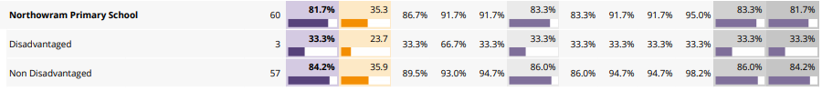
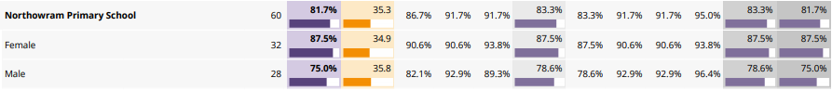

Phonics screening
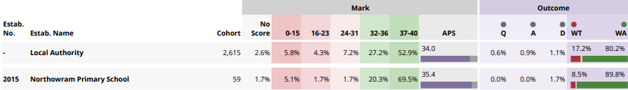

End of KS1
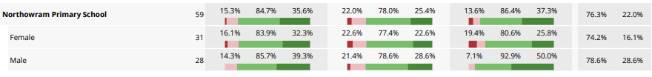
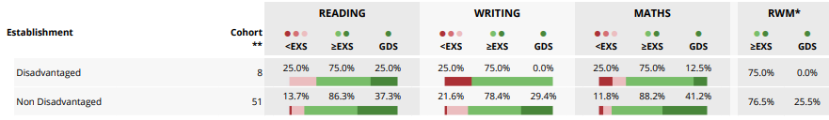

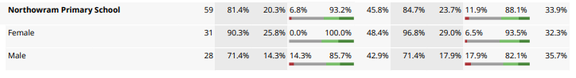
End of KS2
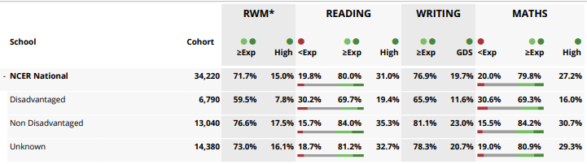

Academic year 2020-2021
Total income £61,175
Additional income received late of £5,500 to be carried over to 2021/2022 budget
Item | Cost
Staffing-  Pupil premium support assistants  Pastoral learning posts (Including contribution towards salary of Head of Pastoral Care and 2 x part time learning mentor posts)  Overtime paid for extra interventions (rainbows and sunbeams)  PP 1:1 support staff member | £22,730  £13,982  £523  £2,584.56
Free school meals for FSM children for Years 3- 6 | £14,683
School uniform | £900
Extra-curricular activities  Drums  Samba | £482  £99
Educational psychologist | £1,500
CPOMS licence | £921.20
Safeguarding Welfare Service | £1,070
Education Welfare Officer | £300
Morrisons school meal boxes | £539.84
Play services | £860.40
 | TOTAL SPEND- £61,175

Barriers to future learning (for pupils eligible for PP including higher ability)
Barrier to learning
A | Low attainment on entry of PP children
B | Significant numbers of children requiring emotional support to be able to access learning
C | Children will be disadvantaged because of home financial constraints (personal equipment)
D | Children’s experiences are limited due to home financial constraints

Outcome | Desired outcomes | Success criteria
A | To increase attainment and progress in Maths and in English (Reading, Writing, SPAG to narrow the gap between PP and national non-PP groups in all year groups. | At the end of KS2 the gap between PP children and non – PP children in school will be reduced and the gap between non-PP children nationally will begin to close.  In EY and KS1 outcomes gap will close between non-PP children nationally.
B | No difference in the engagement of PP and non-PP pupils in lessons – measured through lesson observations and classroom behaviour logs. | All children will receive support they need and there will be no difference between % of children who are PP and % of children who are not PP.
C | Pupils receive support within school and develop personal skills to overcome personal barriers. Pupils will become more aware of how to keep themselves mentally healthy. | Children are able to talk about and deal with their emotions effectively and this will have a lesser impact on their day-today school life.
D | Every child has the correct equipment to succeed in school e.g. uniform, PE kit | Children have a sense of pride in themselves and school.
E | PP children have a sense of pride and have high aspirations for themselves and other members of the school community. | Children have high aspirations of themselves and their future regardless of their circumstances at home.
F | All children will be provided with free school meals to ensure that they receive sufficient nourishment throughout the day. This includes children who are accessing online learning at home. | Children will be provided with sufficient food to be able to learn successfully.

Quality of teaching for all
Desired outcome | Chosen action/approach | What is the evidence and rationale for this choice? | How will you ensure it is implemented well? | Staff lead | When will you review implementation?
A/ B | Increased adult support in some year groups.  Targeted 1:1 support if a child is identified as struggling. | Children whose progress slows or are not at ARE receive in class support to ensure that no child is left behind academically. | Children’s progress reviewed at data assessment points.  Children targeted and tracked. | LH | At data assessment points.

Targeted support
Desired outcome | Chosen action/approach | What is the evidence and rationale for this choice? | How will you ensure it is implemented well? | Staff lead | When will you review implementation?
E | Children in receipt of PP grant receive uniform. | No children are disadvantaged by home circumstance. | All PP children receive vouchers and use of vouchers is monitored. LH to work with office staff to ensure this.  Regular monitoring of uniform in school. | LH | N/A
D | Extra curriculum activities (This has been restricted this year due to Covid 19). | Children who are unable to access these activities out of school are provided with the opportunities to learn something new in school e.g. drums, piano. | Identify children who would benefit from extra-curricular activities.  Activities to be offered to these families and paid for. | LH/ JJ | Ongoing monitoring looking at the number PP children being offered after school clubs / e.g. % of PP children.
C | Learning mentors to be used to support PP children with social and emotional issues. | Social and emotional support to be provided for children with difficult home lives.  Opportunities to be provided to support the children in these circumstances. | Identify children with the support of the pastoral lead.  Review children regularly.  Sessions to be logged on CPOMS when appropriate and followed up.  Sessions to be available to the children on a weekly basis. | JJ/ KS/ AT | Review of the children termly. JJ to meet with learning mentors regularly to review children.
A/C | External agency support for children with identified needs. | Identified PP children to be identified for external support e.g. Education psychologist, 1:1 tuition, play therapy. | Children to be identified with working closely with SEND to identify cross overs between PP and SEND.  Working in partnership with parents to discuss concerns and support. | LH/ AB/ PP team | Reviewed at SEND meetings.

Other approaches
Desired outcome | Chosen action/approach | What is the evidence and rationale for this choice? | How will you ensure it is implemented well? | Staff lead | When will you review implementation?
F | Children in school will receive daily free school meals.  Children who are learning at home will be provided with weekly Morrisons boxes containing food supplies for a week or will be provided with a supermarket voucher to buy food with. | To ensure that all children are provided with the correct nourishment in order to be able to succeed in school. | Set up Morrisons boxes for any bubbles that close or provide vouchers for families.  Monitor the take up and take feedback from parents. | AD | On-going

