

**School Cleaner**

**Applicant Pack**

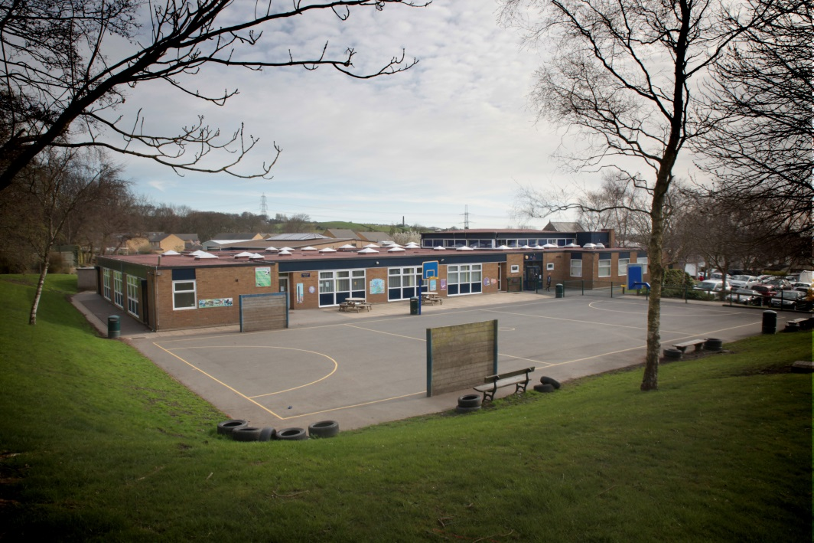

# CONTENTS

|  |  |
| --- | --- |
|  | **PAGE** |
| **Welcome letter** | **3** |
|  |  |
| **Advertisement** | **4** |
|  |  |
| **Timeline/How to apply** | **5** |
|  |  |
| **Safer Recruitment** | **6** |
|  |  |
| **Policy Statement on the**  **Recruitment of Ex-Offenders** | **7** |
|  |  |
| **Job Description** | **9** |
|  |  |
| **Person Specification** | **10** |



**INSPIRING SUCCESS**

**BEYOND EXPECTATION**

Headteacher: Mrs Jane Scardifield****

May/June 2022

Dear Applicant

Thank you for your enquiry regarding the Cleaner vacancy. The following documents are enclosed:

* Applicant Pack
* Application Form
  + (Please ensure that this is fully completed, paying particular attention to the employment history section. The information given must be in the specified format, i.e. dd/mm/yy).
  + When providing details of referees one must be your current or most recent employer. References will not be accepted from relatives or from people writing solely in the capacity of friends.
  + Your application should demonstrate how you meet the criteria shown in the Person Specification.

The position advertised is for 11 hours 15 mins per week (Monday to Thursday 3:30 – 5:45pm and Friday 3:15 – 5:30pm) and the postholder is required to work usually the first 2 weeks in the summer holidays to carry out a deep clean. Hours in the holidays may vary.

We encourage and welcome visits to the school, if you would like to visit or require any further information please contact Ian Wood our Buildings Manager on 01422 202704 (Ext 507) to arrange a visit.

Northowram Primary School is committed to safeguarding and promoting the welfare of children, young people and vulnerable adults and expects all staff and volunteers to share this commitment. The successful applicant will be required to undertake pre-employment checks including references from previous employers, confirmation of right to work in the UK and a DBS check.

I look forward to receiving your application.

Yours sincerely



Jane Scardifield

Headteacher



**Northowram Primary School**

**Baxter Lane**

**Northowram**

**HX3 7EF**

**(Tel: (01422) 202704**

**CLEANER**

**11 hours 15 mins per week**

**All year round**

**£5,574 per year (Scale 1 - Point 1 - £9.50 per hour)**

We currently have a vacancy for two enthusiastic, hard-working and capable people to join our cleaning team. The role involves all aspects of cleaning around the school.

Hours of work are Monday to Thursday 3.30 pm to 5.45 pm and Friday 3.15 pm to 5.30 pm. In school closure periods these hours may differ. The successful postholders will be required to carry out a deep clean usually the first 2 weeks in the summer holidays and other times of the year as directed by the Buildings Manager.

We encourage and welcome visits to the school if you would like to visit or require any further information please contact Ian Wood our Buildings Manager on 01422 202704 (Ext 507) to arrange a visit.

***The school is committed to safeguarding and promoting the welfare of children, young people and vulnerable adults and expects all staff and volunteers to share this commitment. Applicants to posts that are exempted from the Rehabilitation of Offenders Act will require a DBS check from the Disclosure and Barring Service before the appointment is confirmed, in addition to standard pre-employment checks.***

You can apply for this vacancy by downloading the application form and supporting documents from the Calderdale Council website [www.calderdale.gov.uk](http://www.calderdale.gov.uk) or from our website <https://northowram.calderdale.sch.uk/>

Please return your application form via e-mail: [recruitment@northowram.calderdale.sch.uk](mailto:recruitment@northowram.calderdale.sch.uk) or alternatively post to the school no later than **9am on Friday 10th June 2022**. Late applications and CV’s will not be accepted.

# Timeline

Completed applications should be returned (via e-mail or hard copy) no later than 9am on Friday 10th June 2022

# How to Apply

Please complete the application form provided. The Personal Statement should be no longer than 2 sides of A4 and should address the selection criteria detailed in the person specification. Please note that any supplementary submissions in excess of these limits will be disregarded.

Prior to submitting an application, please check that you meet the essential criteria with regard to essential qualifications requested. If you are invited to interview you will be expected to bring your original educational certificates with you.

Please e-mail your completed application (subject heading: “Confidential – Cleaner”) to:

[recruitment@northowram.calderdale.sch.uk](mailto:recruitment@northowram.calderdale.sch.uk)

Applications will also be accepted by post.

If applying by post, please mark the envelope “Confidential – Cleaner” and return to:

Northowram Primary School, Baxter Lane, Northowram, Halifax, HX3 7EF

# Communication

E-mail is our preferred method of communication. Candidates will receive all communication via their e-mail address and we would advise you to check your e-mails on a regular basis.

# Acknowledgement of receipt of applications

We do not acknowledge receipt of paper applications. Applications submitted on line will however, receive an acknowledgement upon request.

# Shortlisted Candidates

Shortlisted candidates will be contacted shortly after the closing date. If you do not hear from us within 4-6 weeks, please assume that on this occasion your application has been unsuccessful.

# Safer Recruitment

Safer recruitment practice aims to minimise the risk of appointing an individual who is unsuitable to work in a post where they will be in contact with children or vulnerable adults and could cause them harm. This school is fully committed to the principles of safer recruitment

Our selection processes observe best practice in selecting the appropriate candidate by ensuring equality of opportunity for all applicants whilst excluding any who may be unsuitable to work with our children. All candidates are expected to understand their own duties and responsibilities in regard to child protection and safeguarding with due relevance to the specific post advertised.

The Disclosure and Barring Service (DBS) helps employers to make safer recruitment decisions and to prevent unsuitable people from working with vulnerable groups, including children. It is a criminal offence to offer (or indeed to apply for, or to accept an offer of) employment in certain designated posts (those which involve working with children in what is defined as regulated activity) to a barred individual.

Accordingly, some or all (depending on the precise role) of the following steps will be taken as part of the recruitment processes:

* Confirmation of identity by sight of original official documents (Birth Certificate, Passport etc)
* Confirmation of professional qualifications (those required to fulfil the post) by sight of original documentation.
* Full scrutiny of employment history with clarification to be sought (from candidate or referees as appropriate) in the event of identified gaps or discrepancies.
* Satisfactory references – a minimum of two written references (one of which must be from most recent employer) will be taken up prior to interview.
* The identity of all referees must be open to verification.

In accordance with DBS regulations all candidates for relevant posts are required to provide details of any relevant unspent convictions. Additionally, for those posts involving “regulated activity”, all “spent” convictions must be disclosed under the Rehabilitation of Offenders Act 1974.

* A DBS check will be requested for appointments to all relevant posts.
* For those involved in “regulated activity” this will include an additional check of the Children’s Barred List.

Any conditional offer of employment will be made strictly subject to receipt of all required documentation (as specified) and satisfactory verification of all checks as above.

# Northowram Primary School

# Policy statement on the recruitment of ex-offenders

New legislation now requires all registered bodies and prospective employers to ensure that any applicants, subject to Disclosure and Barring Scheme (DBS) checks, who have a criminal record must not be unfairly discriminated against because of a conviction or other information revealed.

In addition registered bodies and employers who undertake Regulated Activity (Schools) must have a written policy on the recruitment of ex-offenders, a copy of which can be given to DBS applicants at the outset of the recruitment process.

As a Regulated Activity provider (RAP) all paid employees at Northowram Primary School provide regulated activity and are therefore subject to checks with the DBS.

This policy statement should be read alongside our Equal Opportunities policy.

# Policy Statement

As an organisation using the Disclosure and Barring Service (DBS) checking service to assess applicants’ suitability for positions of trust, Northowram Primary School complies fully with the Code of Practice. We undertake not to discriminate unfairly against any subject of a DBS check on the basis of a conviction or other information revealed.

Northowram Primary School is committed to the fair treatment of its staff, potential staff or users of its services, regardless of race, gender, religion, sexual orientation, responsibilities for dependants, age, physical / mental disability or offending background.

Northowram Primary School actively promotes equality of opportunity for all with the right mix of talent, skills and potential and welcome applications from a wide range of candidates, including those with criminal records. We select all candidates for interview based on their skills, qualifications and experience.

In relation to volunteers and contractors, we only request a DBS check after a thorough risk assessment has indicated that one is both proportionate and relevant to the position concerned.

For those positions where a DBS check is required, all application forms, job adverts and recruitment briefs will contain a statement that a DBS check will be requested in the event of the individual being offered the position.

We encourage all applicants called for interview to provide details of their criminal record at an early stage in the application process. We request that this information is sent (under separate, confidential cover) to the Head teacher and we guarantee that this information will only be seen by those who need to see it as part of the recruitment process.

We ensure that all those in our school who are involved in the recruitment process have been suitably trained to identify and assess the relevance and circumstances of offences. We also ensure that they have received appropriate guidance on the relevant legislation relating to the employment of ex-offenders, e.g. the Rehabilitation of Offenders Act 1974 and know how to access advice and support e.g. from our HR service, registered body, the DBS, etc.

At interview, or in a separate discussion, we ensure that an open and measured discussion takes place on the subject of any offences or other matter that might be relevant to the position. Failure to reveal information that is directly relevant to the position sought could lead to withdrawal of an offer of employment.

We undertake to discuss any matter revealed in a DBS check with the person seeking the position before withdrawing a conditional offer of employment. This discussion and any subsequent risk assessment may be undertaken by senior leaders in school or by our HR service.

# NORTHOWRAM PRIMARY SCHOOL

# JOB DESCRIPTION

The information given on this job description is intended to provide an understanding and appreciation of the workload of this particular job and its purpose within the organisation.

The job description outlines main duties and responsibilities under broad headings only, as it is not possible to specify every item in detail.

**POST TITLE: Cleaner**

**GRADE: Scale 1 (SCP 1)**

**PRIME OBJECTIVES OF THE POST**

Maintain a good standard of cleanliness in the areas which you are allocated by using the correct methods, materials and cleaning equipment.

**RESPONSIBLE TO**

Buildings Manager

**RESPONSIBLE FOR (number of staff)**

There is no requirement to manage other members of staff in this role.

**MAIN DUTIES AND RESPONSIBILITIES**

* Vacuum carpets
* Shampoo carpets as required
* Brush/sweep flooring
* Mop flooring
* Wipe classroom desks (daily, but removing obvious stains when required)
* Clean toilet floors daily
* Clean sinks and toilets daily
* Wipe shelves, window ledges and bookcases
* Remove any marks and stains from walls/floors as necessary
* Scrub classroom floors and toilet floors with scrubbing machine
* Report repairs required to the cleaning equipment, school furniture and building to the Buildings Manager.
* Empty bins and take rubbish outside to external refuse area daily.
* Security of equipment and materials
* Full summer “spring clean” as instructed by the Buildings Manager
* Any other duties as requested by the Buildings Manager

**PERSON SPECIFICATION**

**Note to Applicants:**

Criteria marked as essential are the key requirements. You should pay particular attention to these areas and provide evidence of meeting them. Failure to do so may mean that you will not be invited for interview.

Achievement of criteria – key to identification

A = Application I = Interview E = Exercise R = Reference

|  |  |  |  |
| --- | --- | --- | --- |
| **Knowledge & Skills (including any relevant or required qualifications)** | **Essential** | **Desirable** | **How**  **identified** |
| Ability to understand and follow verbal and written instructions | 🗸 |  | A/R |
| Ability to work under pressure | 🗸 |  | A/I |
| Ability to communicate with staff, pupils, parents and contractors | 🗸 |  | A/I/R |
| Knowledge of cleaning processes |  | 🗸 | A/I |
| Knowledge of Health & Safety procedures |  | 🗸 | A/I |
| Ability to use cleaning equipment |  | 🗸 | A/I |
| **Personal Development and Additional Learning** | **Essential** | **Desirable** | **How**  **identified** |
| Willingness to participate in development and training opportunities (can be out of working hours) | 🗸 |  | A/I |
| An understanding of safeguarding and the need for confidentiality |  | 🗸 | A/I |
| **Experience** | **Essential** | **Desirable** | **How**  **identified** |
| Experience of working as part of a team | 🗸 |  | A/I/R |
| Previous experience of cleaning in a school or commercial environment |  | 🗸 | A/I/R |
| **Initiative** | **Essential** | **Desirable** | **How**  **identified** |
| Ability to make decisions required when organising priorities within own workload | 🗸 |  | A/I/R |
| **Circumstances** | **Essential** | **Desirable** | **How**  **identified** |
| Ability to lift cleaning materials and move equipment around school | 🗸 |  | A/I/R |
| Ability to cover for absences and work flexibly when required | 🗸 |  | A/I |